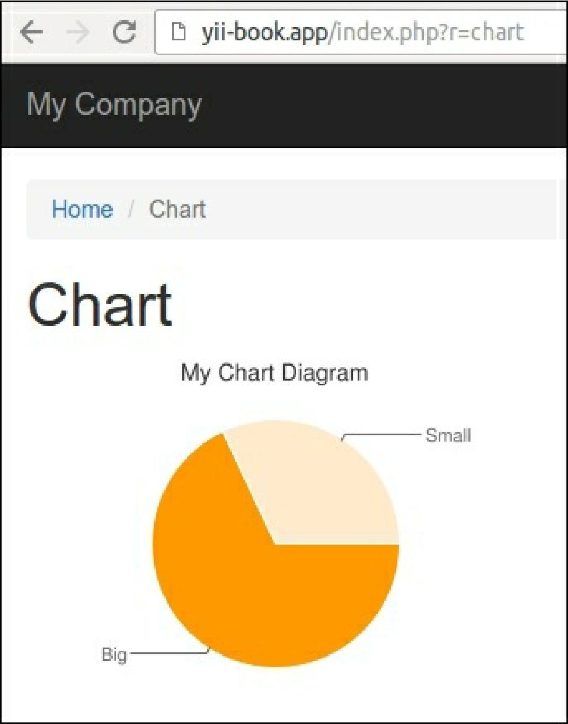

6. You can show any chart with different sizes and data sets.

How it works...

As in every other type of extension, we are creating some public properties we can configure when calling a widget using its widget method. In this case, we are configuring the title, data set, and data labels.

The main method of a widget is run(). In our widget, we are generating a URL and rendering the widget view, which uses the Google charting API for printing the <img> tag.

See also

• [To learn more about widgets, refer to http://www.viiframework.com/doc-2.0/guide-structure-](http://www.yiiframework.com/doc-2.0/guide-structure-widgets.html) widgets.html

• The Making extensions distribution-ready recipe in this chapter